

**Computer & Electronic Engineering**

**Final Year Project "Music Host Interface"**

**Sprint 3: Week 1 Log**

**Thomas Flynn**

**Project Supervisor: Brian O'Shea**

**29/11/15**

**Update:**

My supervisor recommended this [link](https://docs.oracle.com/javase/tutorial/sound/sampled-overview.html) to me to research for the audio aspect of my project.

In sprint 1 I made the wise the decision to research design patterns before delving into code. This has paid off because JavaFX uses the Model View Controller design pattern.

I have managed to install JavaFX scene builder for Netbeans IDE. This will help me significantly in laying out my GUI.

I made the decision to change from a local mySQL database for the host's music selection to a cloud based database using Microsoft Azure.

**Research done:**

JavaFX works through the MVC design pattern.

A **controller** can send commands to the model to update the model's state (e.g., editing a document). It can also send commands to its associated view to change the view's presentation of the model.

A **model** stores data that is retrieved according to commands from the controller and displayed in the view.

A **view** generates an output presentation to the user based on changes in the model.

Microsoft Azure is a cloud computing platform and infrastructure, created by Microsoft for building, deploying and managing applications and services through a global network of Microsoft-managed and Microsoft partner hosted datacenters.

The main advantage of putting the database on the cloud for this project will be so that the host's music selection can being accessed anywhere in the world.

[Link to Azure tutorials](https://www.youtube.com/watch?v=gwqrZasHi4I)

**Tasks completed:**

JavaFX GUI displays input from Client

installed scenebuilder for Netbeans

sceneBuilder tutorial

Microsoft Azure Cloud Software installed

Successfully wrote to the database on the cloud.

Laid out GUI in SceneBuilder

Created Login Scene

Created Bluetooth chat Scene

Created Primary Scene

Primary scene play and skip song buttons working

**JavaFX scene Builder in NetBeans IDE:**

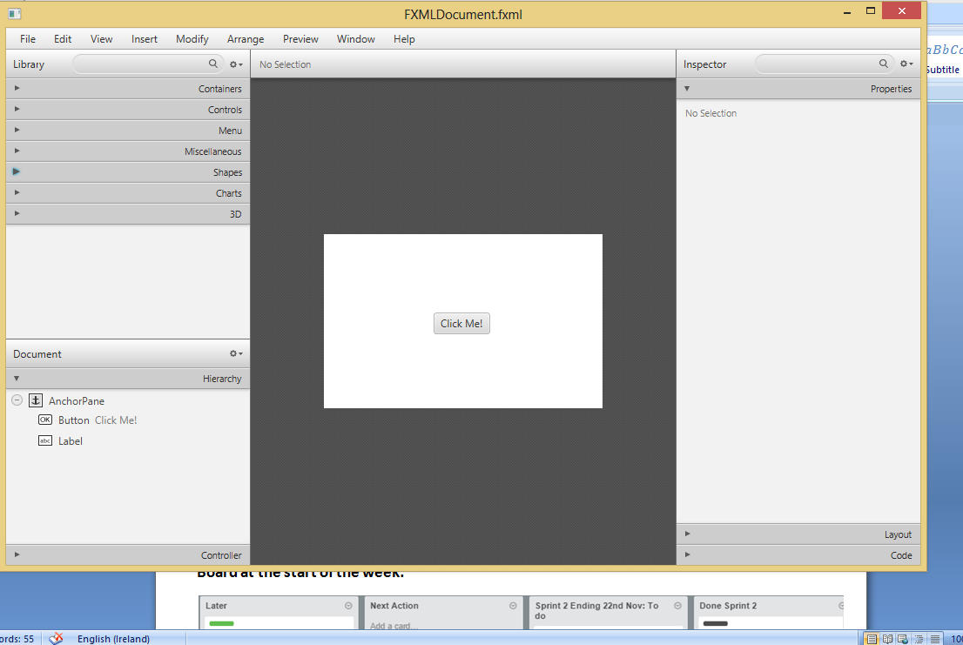

**Cloud database management: Microsft Visual Studio**

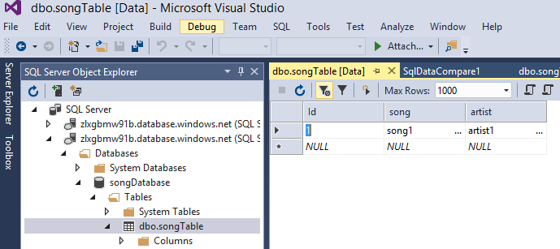

**Microsoft Azure Portal viewer on browser:**

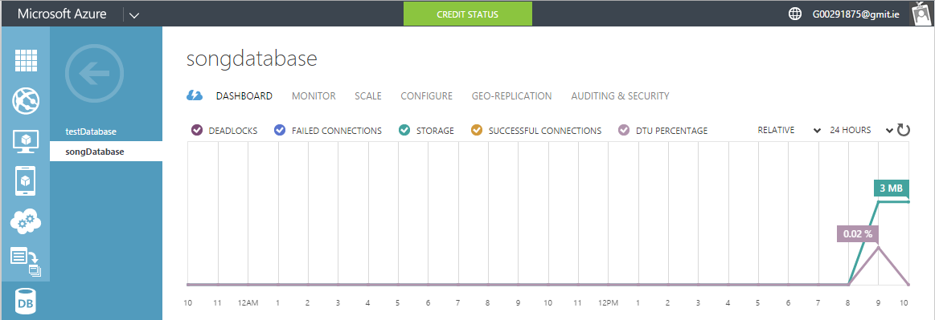

**Viewing cloud database on IntelliJ IDE:**

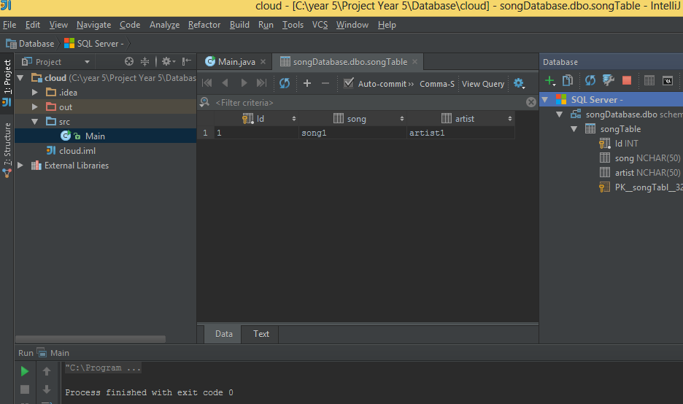

**Board at the start of the week:**

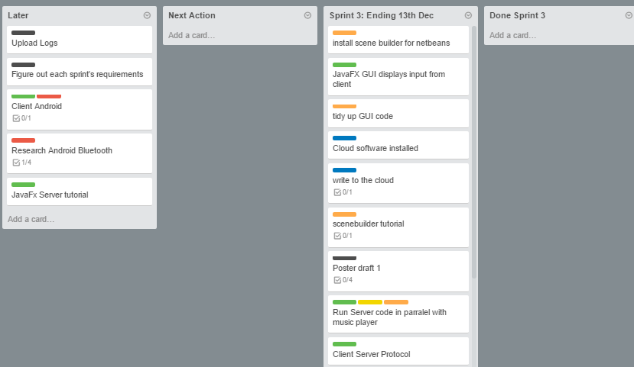

**Board at the end of the week:**

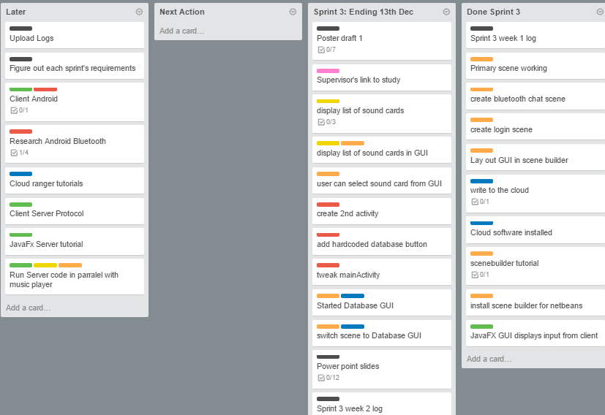

**Weekly time Log bar chart:**

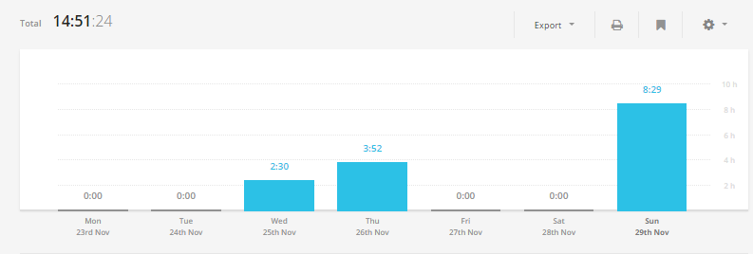

**Weekly Time Log:**

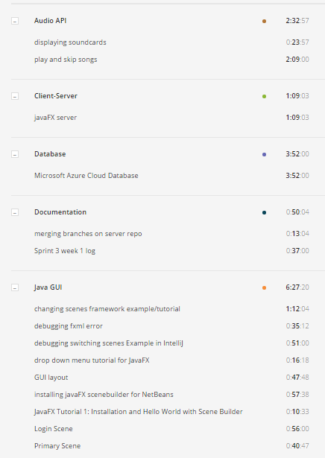

**Weekly log Pie Charts:**

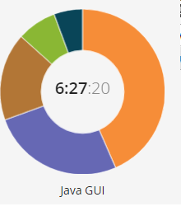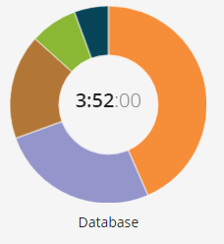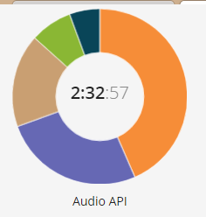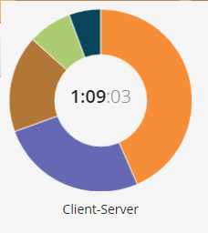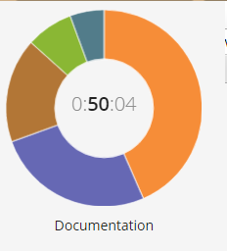

**Links to my GitHub Repositories:**

[FYP-Server](https://github.com/g00291875/FYP-Server)

[FYP-Android](https://github.com/g00291875/FYP-Android)

[FYP-GUI](https://github.com/g00291875/FYP-GUI)

[FYP-Database](https://github.com/g00291875/FYP-Database)

**Link References:**

<https://docs.oracle.com/javase/tutorial/sound/sampled-overview.html>

<https://www.youtube.com/watch?v=gwqrZasHi4I>